ORGANISATION OF WORLD AIDS DAY

Department Of Social Work, The Oxford College Of Arts (Toca) Organizes A Webinar On 4th December 2021 From 10:30 Am To 3:00 Pm With The Theme: “End Inequalities. End Aids. End Pandemics”
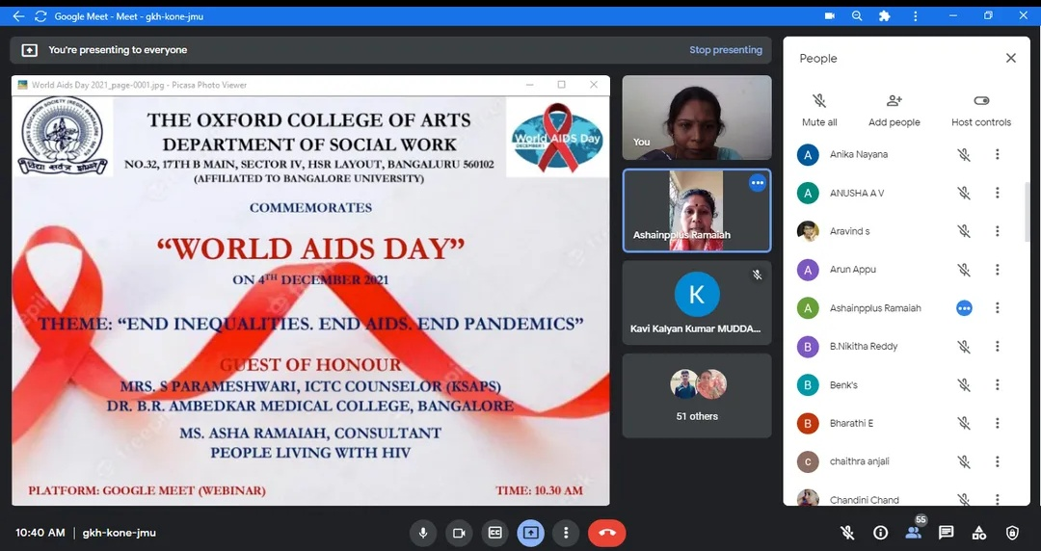

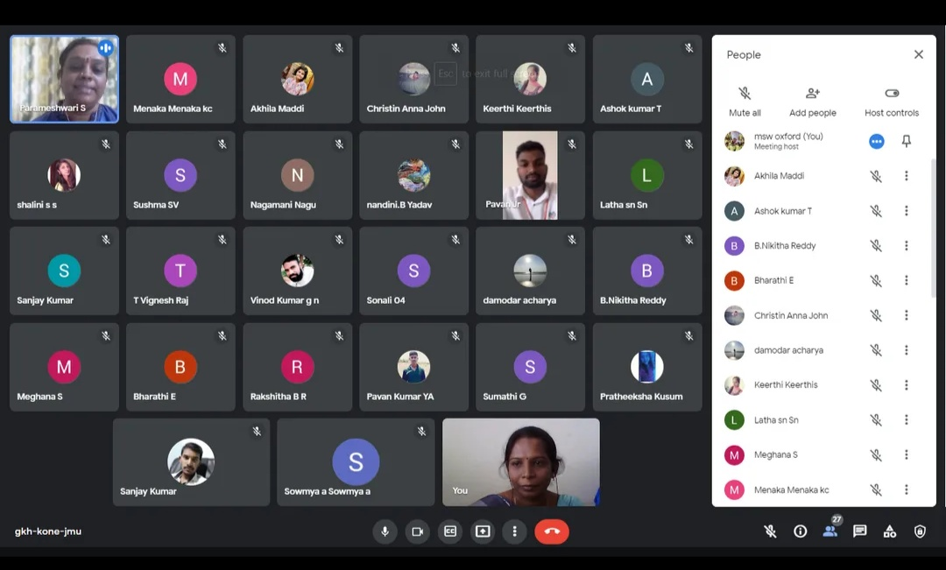
1st Session By Ms. Asha Ramaiah
Topic: Problems, Issues And Support System For The People Living With Hiv/Aids

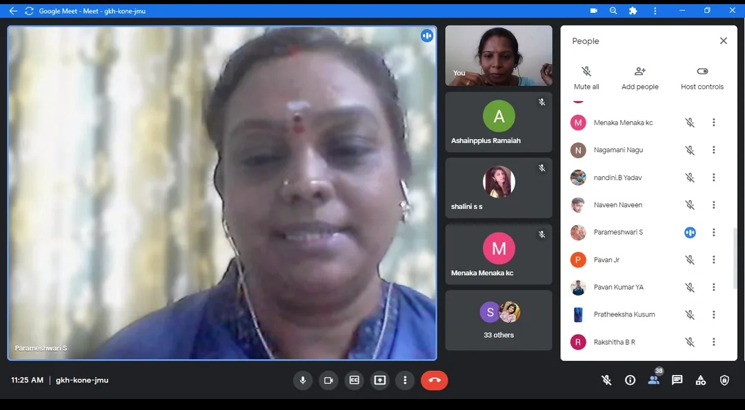
2nd Session By Mrs. S Parameshwari
Topic: Counseling For Hiv/Aids – Issues and Challenges

"INTERNATIONAL DAY OF PERSONS WITH DISABILITIES"
THEME 2021: “LEADERSHIP AND PARTICIPATION OF PERSONS WITH DISABILITIES TOWARD AN INCLUSIVE, ACCESSIBLE AND SUSTAINABLE POST-COVID-19 WORLD”
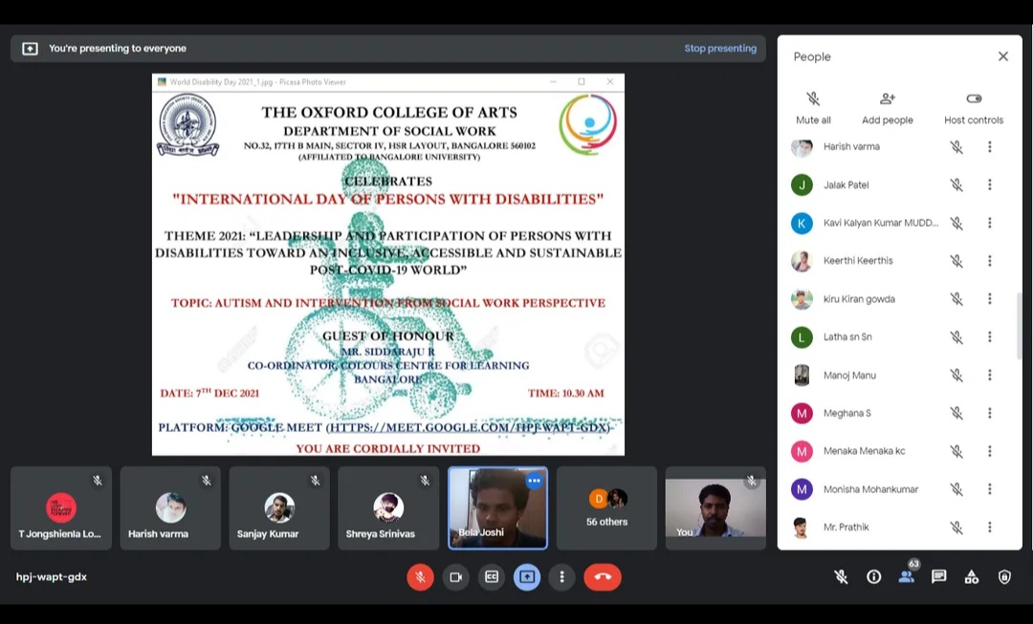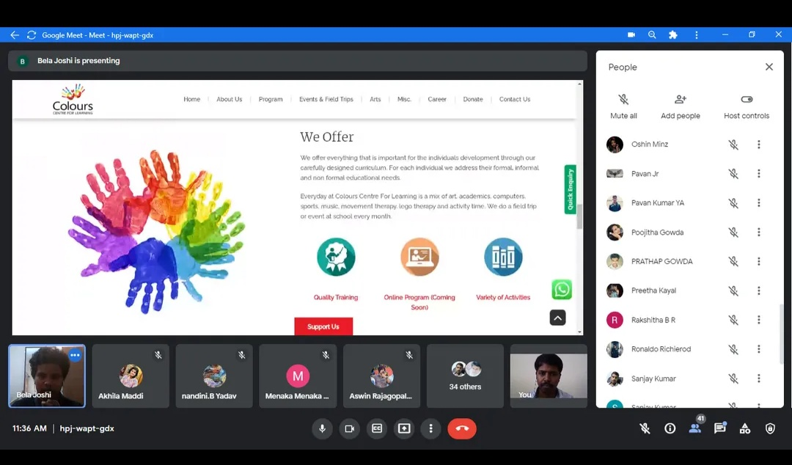
Department of Social Work, The Oxford College of Arts (TOCA) organized a webinar on "AUTISM AND INTERVENTION FROM SOCIAL WORK PERSPECTIVE" by the Guest Of Honour Mr. Siddaraju R, Co-Ordinator, Colours Centre for Learning on 7th December 2021.
WORLD HUMAN RIGHTS DAY

Department of Social Work and Human Rights Cell The Oxford College of Arts organised webinar on “WORLD HUMAN RIGHTS DAY" on 15th December 2021
THEME: “EQUALITY - REDUCING INEQUALITIES ; ADVANCING HUMAN RIGHTS"

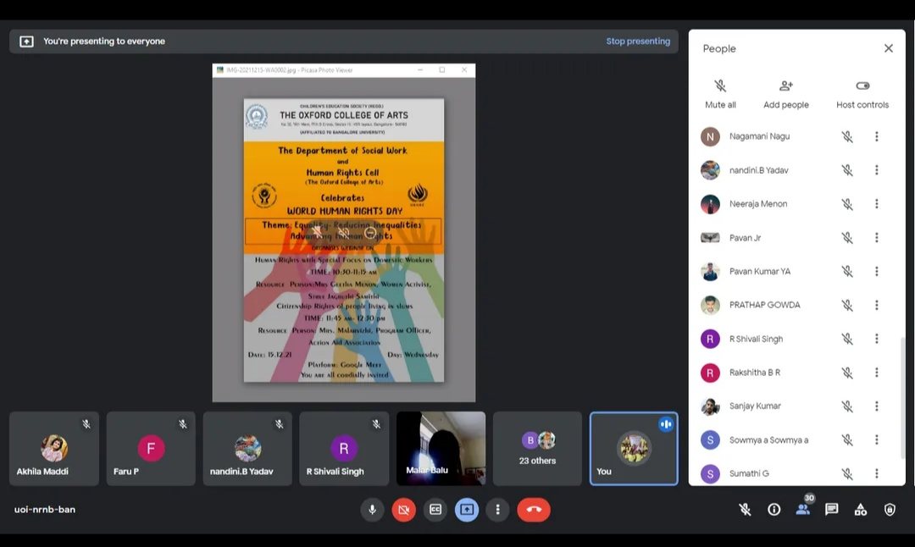
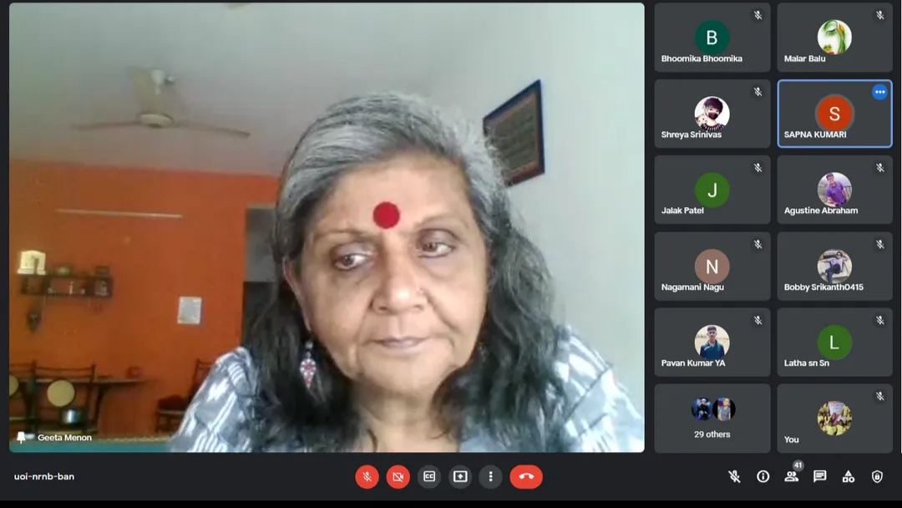

SESSION 1
Topic : HUMAN RIGHTS WITH SPECIAL FOCUS ON DOMESTIC WORKERS
Resource Person -Mrs. GEETHA MENON, Women Activist, Street Jagruti Samithi, Bangalore

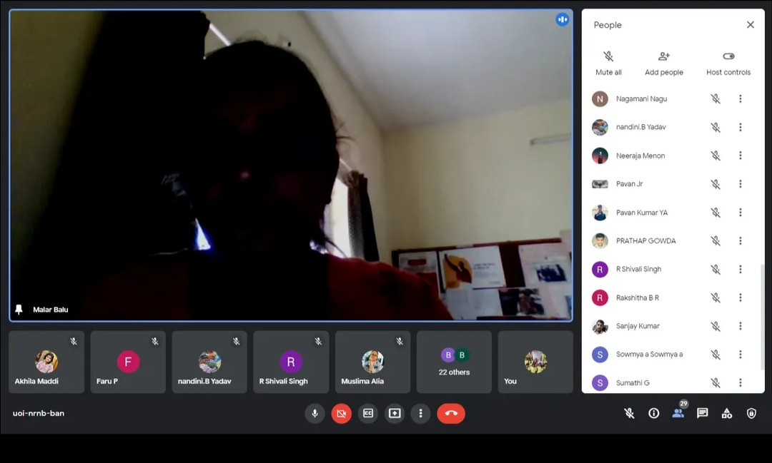

SESSION 2:
Topic :Citizenship Rights of People Living in Slums
Resource Person : MALARVIZHI
Program Officer,
Action Aid Association

CELEBRATION OF WORLD SOCIAL WORK DAY BY THE DEPARTMENT 2020- 2021

The Department of Social work celebrated the World Social Work Day on 17th March. The oath of Professional Social Work was taken by the Trainee Social Workers. As the part of special the occasion the department has Conducted Workshop on Trafficking in Persons. Mr. Hamlet Roy and Team from Talaash Association conducted the activity oriented workshop and the Students of the Department and The Oxford College of Arts have actively participated.
